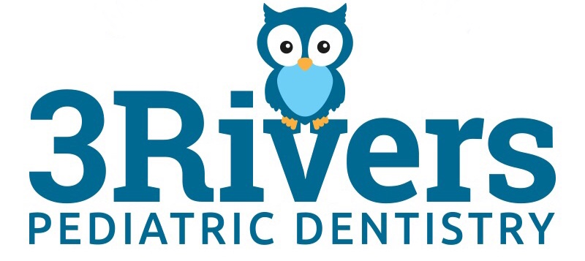

Parent Guidelines for all Child Patients

Welcome to 3 Rivers Pediatric Dentistry!
3 Rivers Pediatric Dentistry strives to provide exceptional dental care to infants, children, teens, and those with special needs. We view every patient as an individual and partner with families to care for their specific needs and promote a lifetime of strong oral health. 3 Rivers Pediatric Dentistry works to treat all patients with compassion and respect in a fun, educational, and kid-centered environment.

How can you help my child be comfortable if they don’t want dental treatment?
We try our best to create a fun environment that isn’t threatening. Windows, bright colors, toys and movies at every chair all complement our friendly team as we guide kids through the dental experience. For higher levels or anxiety, this might not be enough. Laughing gas (Nitrous Oxide) is a safe and effective way to help many of these patients. It even wears off before your child leaves the dental chair. For other patients, we have them drink a medicine to help them tolerate (and in many cases, forget) dental treatment. The medicine does not put children to sleep (although some may take a nap.). Children will continue to safely breathe on their own and maintain their protective reflexes. This is called oral conscious sedation. We are happy to discuss what is most suitable for your child’s needs.

Can I stay with my child during their dental visit?
Yes! There are a number of reasons that we enjoy allowing you to share in your child’s dental experience. It can serve as a comfort to many children to have their parents join them. We team up with parents to support healthy habits at home. Many children have a heightened fear of the unknown. Others will have their attention spans challenged while sitting for a dental procedure. It helps if you could allow us to guide our patients through these obstacles. There are, however, times when such a nice gesture becomes a challenge. Squeezing your child’s hand in anticipation of what you may expect to be uncomfortable can alert them to get worried too. Children can cry to communicate not only pain, but also fear, or if they are simply unhappy with a situation. A cry is going to bring our treatment to a stop so that we can find out how to solve the problem if a parent interjects in response to a cry we may lose the ability to do so. Please let us try first.

Pediatric Dental Terminology
In order to create a positive experience for your child, we are selective in our use of words. We avoid words that might frighten or worry your child. Please support us by NOT using the scary words and not correcting your child if they choose to use our equivalents.

DON’T USE WE USE THIS
Needle/shot Sleepy Juice
Drill Mister Whistles/Mister Bumpy
Drill on tooth Wash the sugar bugs out
Pull or yank tooth Wiggle a tooth out
Decay or cavity Sugar bugs
Examination Count teeth
Tooth cleaning Tickle teeth clean
Explorer Tooth counter
Gas, nitrous oxide Astronaut mask
X-rays or radiographs Tooth pictures

Emergency Treatment
If your child has an emergency, don’t hesitate to call our office (406) 393-3773. A dentist and staff member are always on call.

I acknowledge and agree to the guideline of 3 Rivers Pediatric Dentistry.

__________________________________________
Parent/Legal Guardian Signature

